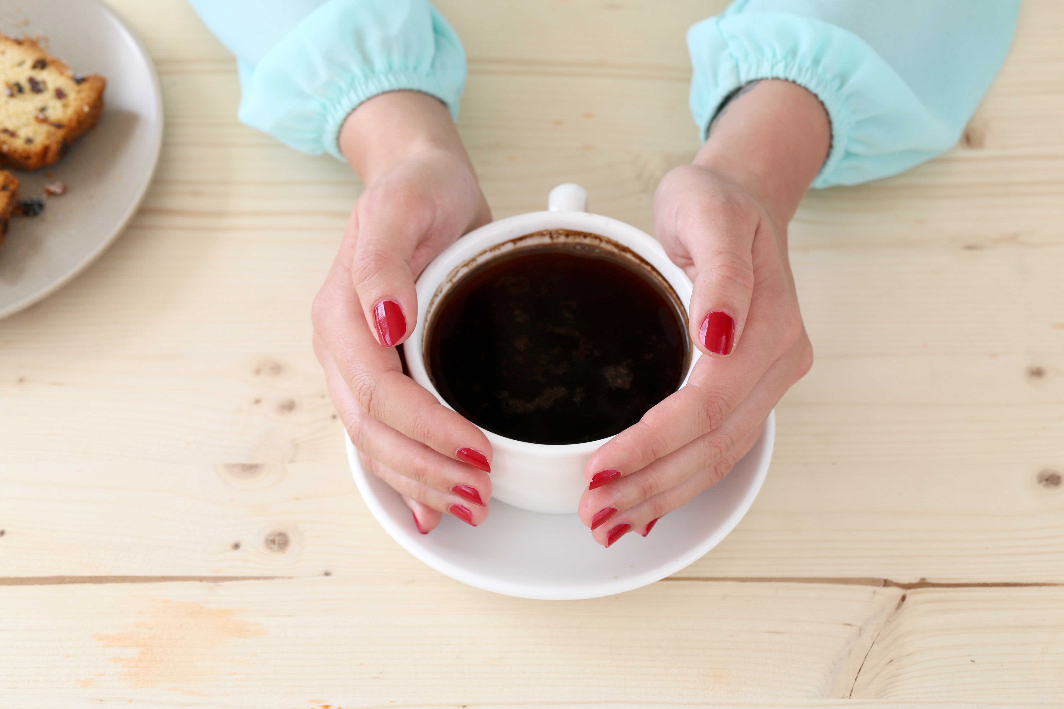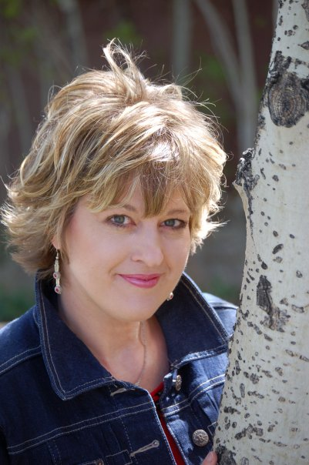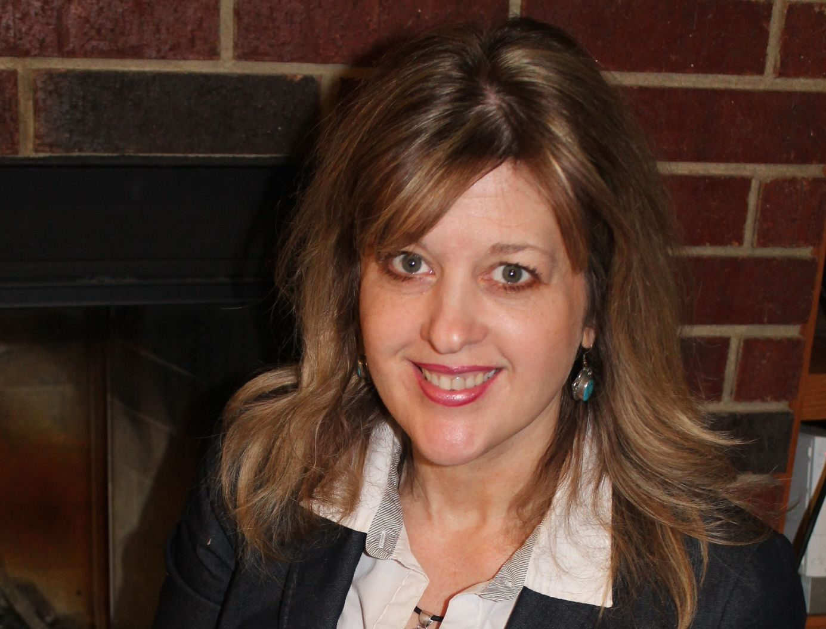

This is the place where **Renae Brumbaugh** is supposed to provide impressive things for you to read. But since the most impressive thing about her is the fact that she almost won a car in one of those little fast-food scratch-off games one time, years ago, but she didn’t actually scratch off the car until she found the card in her desk drawer, long after the deadline had passed . . . there’s not much to say.

But if you really want to know about her writing stuff, she’s the author of many books, has made the ECPA Bestseller list twice, and has contributed to many more books. She’s written hundreds of articles for national publications, and has won awards for her humor.

She’s married to a real hunk, and she’s a mom to some amazing kids. She writes music, sings, and likes to perform on stage. She’s a sometimes school-teacher, an all-the-time wannabe superhero. Her favorite color is blue, unless you’re talking about nail polish, in which case her favorite color is Bubblegum Pink.

# *About the Funny Coffee Girl . . .*

Lessons for Life from a Scatterbrained Wife . . .

*Proverbs 17:22*

Caffeine for the Soul

### More about Renae …

Renae is married to a real hunk, and she’s a mom to some amazing kids. She writes music, sings, and likes to perform on stage. She’s a sometimes school teacher, a part-time farmer, and an all-the-time wannabe superhero. Her favorite color is blue, unless you’re talking about nail polish, in which case her favorite color is Bubblegum Pink.

Renae will be glad to share her stories, insights, and asparagus recipes with your group. And she might even wear her cape, if it’s not at the drycleaners.

#### For more information, contact [Renae@RenaeBrumbaugh.com](mailto:Renae@RenaeBrumbaugh.com), or call

#### 254-289-9893.

#### www.RenaeBrumbaugh.com

Renae Brumbaugh